**C programming**

* **Structure:** C programs are built with functions, and a main() function is mandatory.
* **Keywords:** Reserved words with predefined meanings (e.g., int, if, for).
* **Data Types:** Define the type of data a variable can hold (e.g., int, char, float).
* **Variables:** Named storage locations for data.
* **Operators:** Symbols that perform operations on data (e.g., +, -, *, /).
* **Control Flow:** Determines the order in which statements are executed (using if, else, loops like for and while).
* **Functions:** Reusable blocks of code that perform specific tasks.
* **Input/Output:** printf() for displaying output and scanf() for reading input.
* **Constants:** Fixed values that do not change during program execution.
* **Comments:** Used to explain the code (e.g., // for single-line and /* */ for multi-line).
* **Escape Sequences:** Special character sequences used to represent characters not directly available on the keyboard (e.g., \n for newline).

( Example )

#include <stdio.h>  
  
int main() {  
 int age = 30; *// Integer variable*  
 char name[] = "John Doe"; *// Character array (string)*  
 pri return 0;ntf("Name: %s, Age: %d\n", name, age); *// Output*

*}*

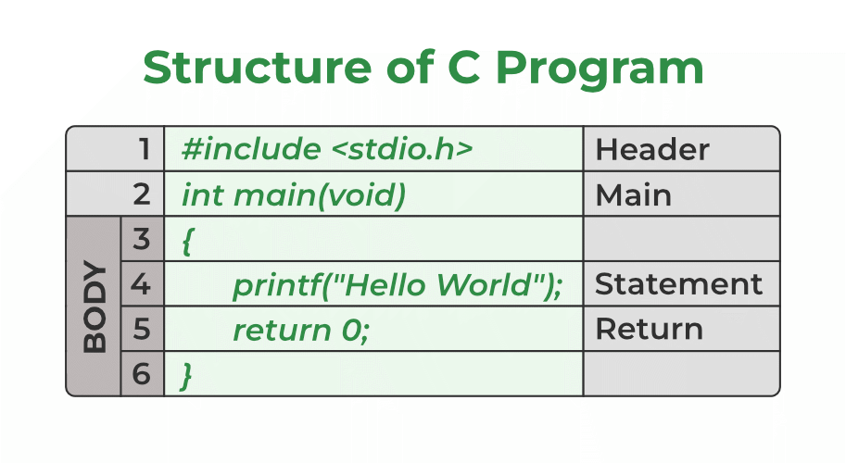

The c program

* C is a general-purpose programming language created by Dennis Ritchie at the Bell Laboratories in 1972.
* It is a very popular language, despite being old. The main reason for its popularity is because it is a fundamental language in the field of computer science.
* C is strongly associated with UNIX, as it was developed to write the UNIX operating system.